# Project Design Phase-II

**Data Flow Diagram & User Stories**

|  |  |
| --- | --- |
| Date | 16 October 2022 |
| Team ID | PNT2022TMID02471 |
| Project Name | IOT BASED SMART CROP PROTECTION SYSTEM |
| Maximum Marks | 4 Marks |

## Data Flow Diagrams:

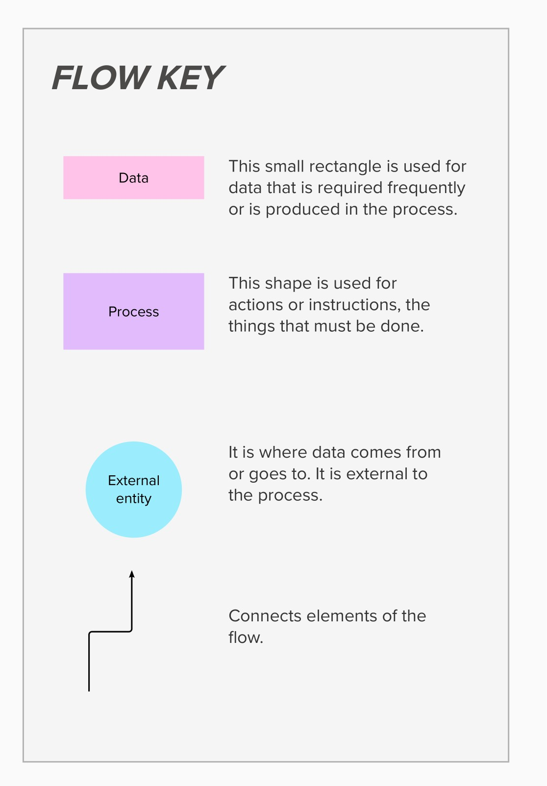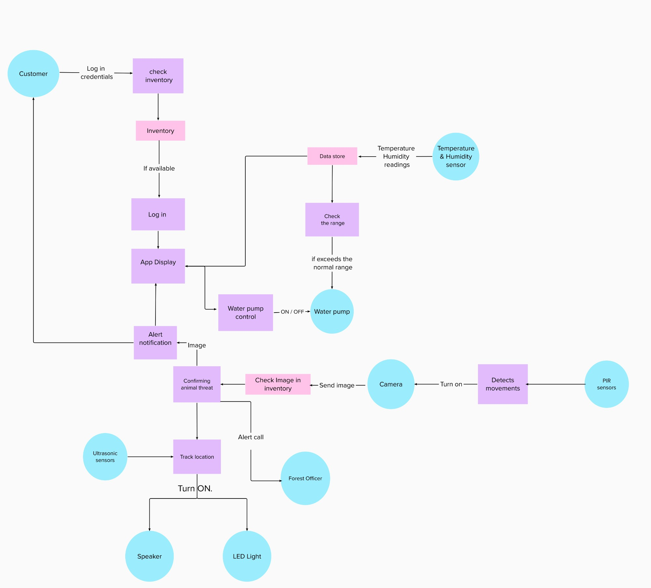

**User Stories:**

Use the below template to list all the user stories for the product.

|  |  |  |  |  |
| --- | --- | --- | --- | --- |
| **User Type** | **Functional**  **Requirement (Epic)** | **User Story**  **Number** | **User Story / Task** | **Acceptance criteria** |
| Customer  (Mobile user) | Registration | USN-1 | As a user, I can register for  the application by entering my email, password, and  confirming my password. | I can access my account /  dashboard |
|  |  | USN-2 | As a user, I will receive  confirmation email once I have registered for the  application | I can receive confirmation email & click confirm |
|  |  | USN-3 | As a user, I can register for the application through  Gmail |  |
|  | Login | USN-4 | As a user, I can log into the  application by entering email & password | I can access my account / dashboard |
|  | Dashboard | USN-5 | As a user,I can view all  activities in the farm from dashboard | I can monitor the farm |
|  | Weather  Condition | USN-5 | As a user,I can view the  temperature and humidity level through Application | I can analyze the  Temperature and humidity level in the Farm |
|  |  | USN-6 | As a user I can receive the  Weather Condition Alerts in farm through Application | I can access Weather  Condition in that particular area |
|  | Soil moisture  condition | USN-7 | As a user, I can view  moisture levels in Soil through an application. | I can analyze the soil  moisture level in that field |
|  | Crop  Irrigation | USN-8 | As a user, I can remotely  control the water pump through the mobile app | I can turn ON/OFF and  control the water pump |
|  |  | USN-9 | As a user, I can  automatically irrigate my farm using the soil moisture sensors | My farm can be  automatically irrigated |

|  |  |  |  |  |
| --- | --- | --- | --- | --- |
| **User Type** | **Functional**  **Requirement (Epic)** | **User Story**  **Number** | **User Story / Task** | **Acceptance criteria** |
|  | Alert  Notification | USN-10 | As a user, I can receive alert  notification through the app when an animal which is a threat to the farm is entering into the farm | I can receive the notification  from the app |
|  |  | USN-11 | As a user, I can receive alert email when an animal which is a threat is entering into the farm | I can receive an alert through email |
|  | Drive away  animals | USN-12 | Turning ON the speaker at a  specific location where the animal is intruding | Speakers can be turned ON  automatically |
|  |  | USN-13 | Turning ON the LED incase  of animal intrusion during night time | LED can be turned ON  automatically |
|  | Power supply | USN-14 | The Power is generated by  the solar panel for running the motor. | Power is generated  automatically from sunlight |
|  | Detection of  animals | USN-15 | As a user, I can detect the  animals through the movement | I can receive information  through application |
|  |  | USN-16 | As a user, I can detect the  animals through the sound | I can receive information  through application |
|  |  | USN-17 | As a user, I can view the  animals through the camera | I can receive information through application |
| Customer care  executive | Receiving feedbacks | USN-18 | As a user, I can receive the customer feedbacks through google forms | I can receive the feedbacks |
|  |  | USN-19 | As a user, I can receive the queries of the customer through the interactive chat platform | I can receive the notification when customer is posting a query |
|  | Replying to the queries | USN-20 | As a user, I can reply to the queries of the customer | I can send reply in the interactive chat platform |